**Allure report Configuration**

Allure Framework is a flexible lightweight multi-language test report tool. Easy to Configure with any kind of projects.

Contents

* **Installation**
* **Configuration with Project**
* **Report Generation Process**

1. **Installation**

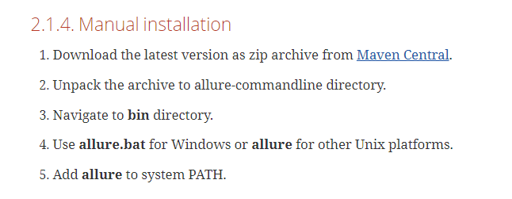

* **Click Enter on Below Hyper link to Download Allure server Manually**

[**https://github.com/allure-framework/allure2/releases/tag/2.13.7**](https://github.com/allure-framework/allure2/releases/tag/2.13.7)

* Click on Zip file to download.

[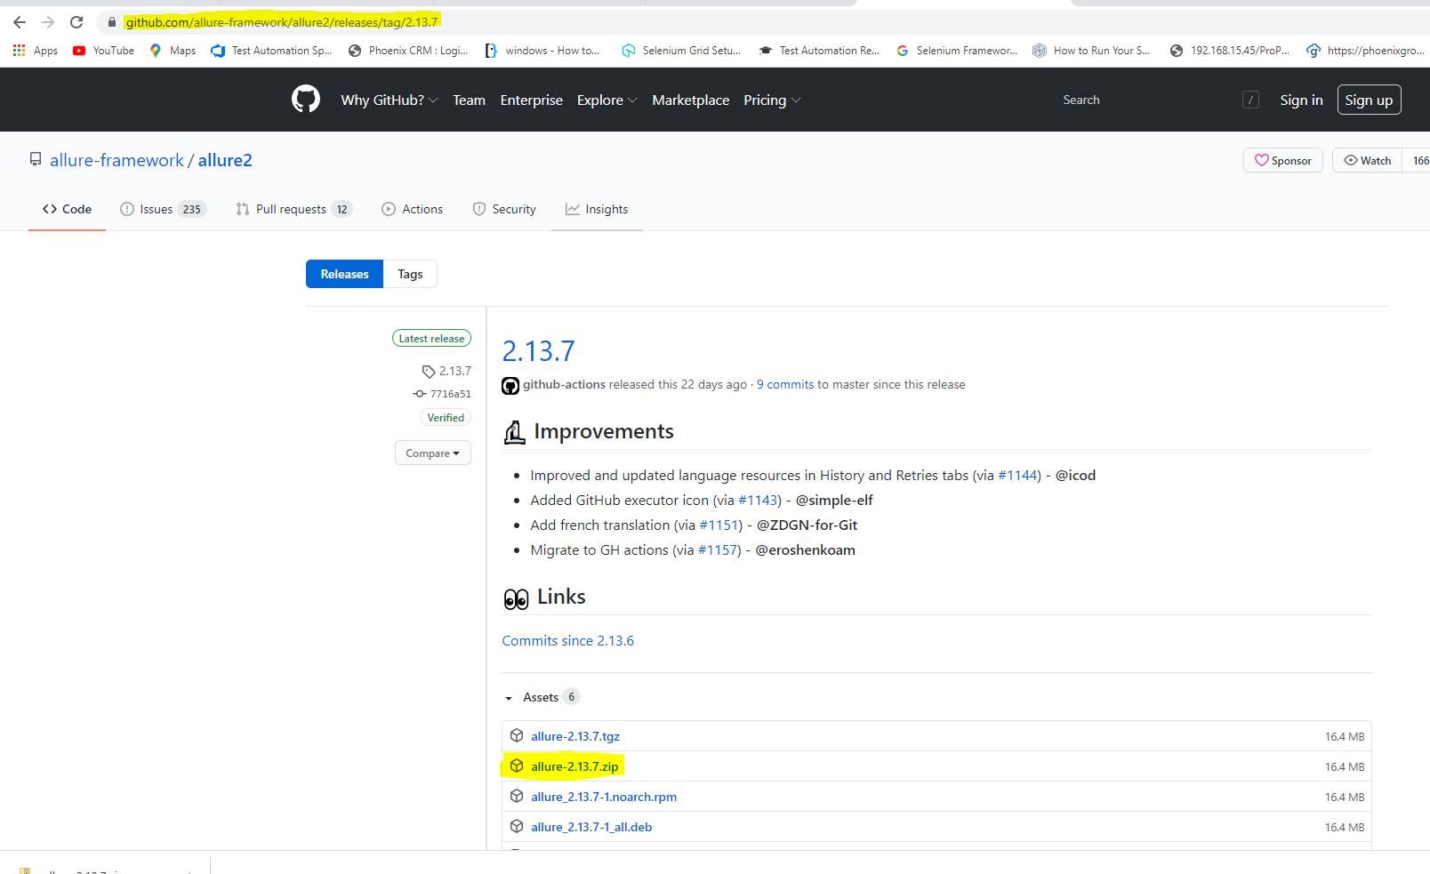](https://github.com/allure-framework/allure2/releases/tag/2.13.7)

* **Extract files from Zip file and Copy Extracted Folder to C:Program Files/**

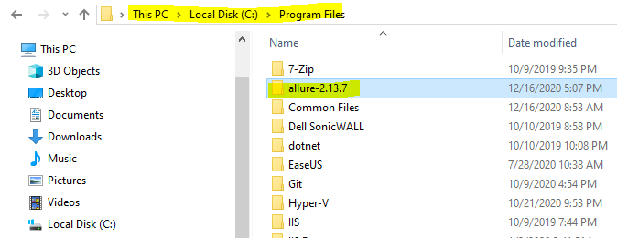

* **Set environment variable and System variable for allure server.**

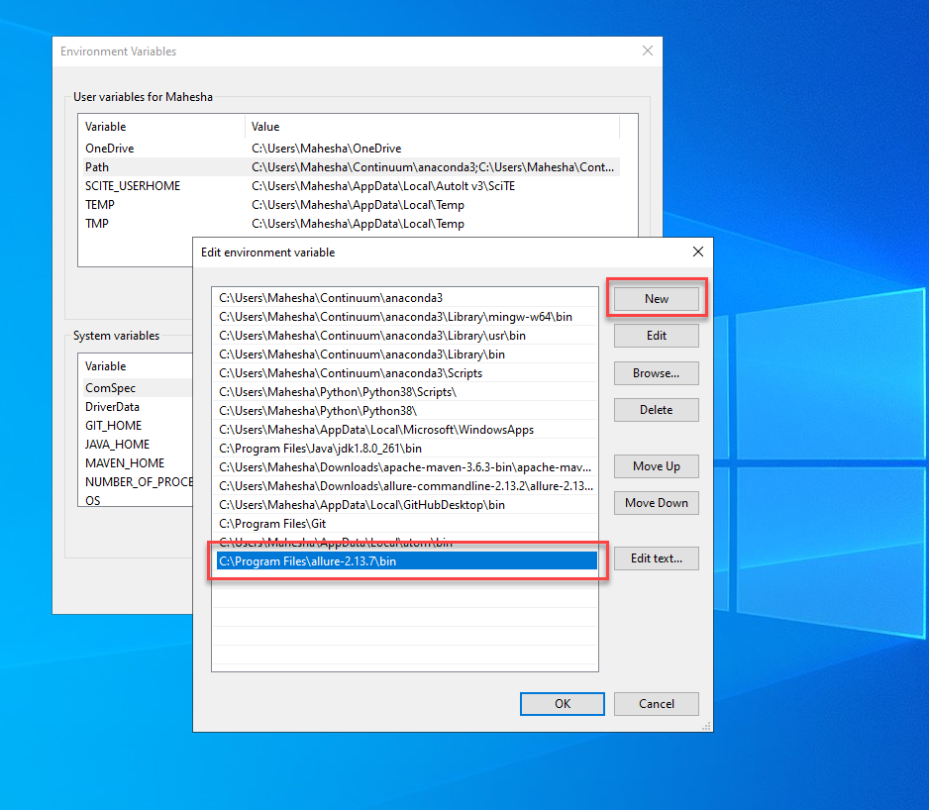

* Check Allure server Configured with Machine From Command prompt

By Passing Command as below

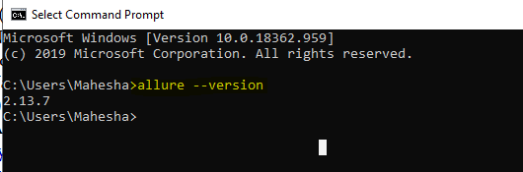

1. **Configuration with Project**

* **Copy below Maven repository and paste in Pom.xml of the Project as shown**

[**https://mvnrepository.com/artifact/io.qameta.allure/allure-testng/2.13.7**](https://mvnrepository.com/artifact/io.qameta.allure/allure-testng/2.13.7)

<!-- https://mvnrepository.com/artifact/io.qameta.allure/allure-testng -->

<dependency>

<groupId>io.qameta.allure</groupId>

<artifactId>allure-testng</artifactId>

<version>2.13.7</version>

</dependency>

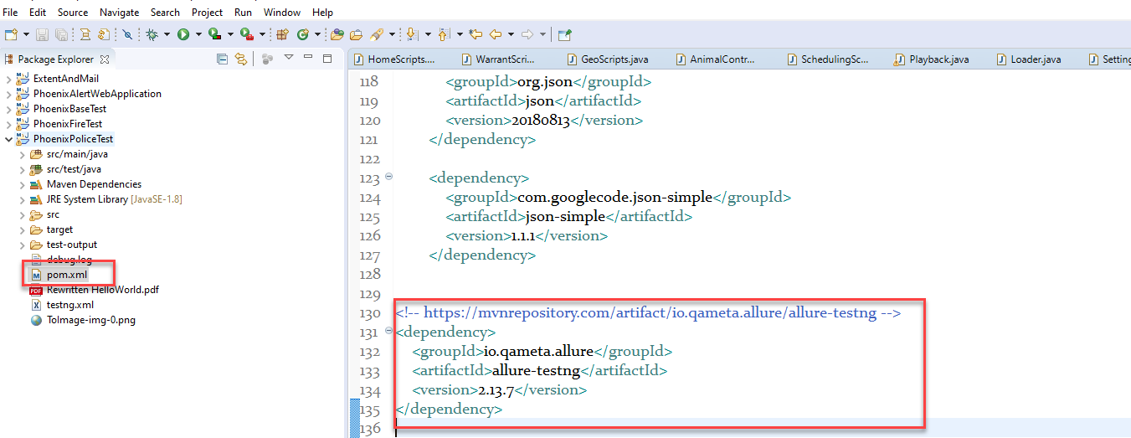

* **We Can start running our scripts**

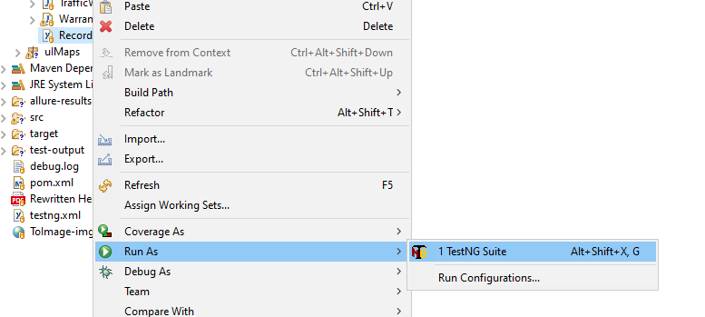

* **After Completing all the test Refresh the project So It will enable**

**allure-results folder as shown.**

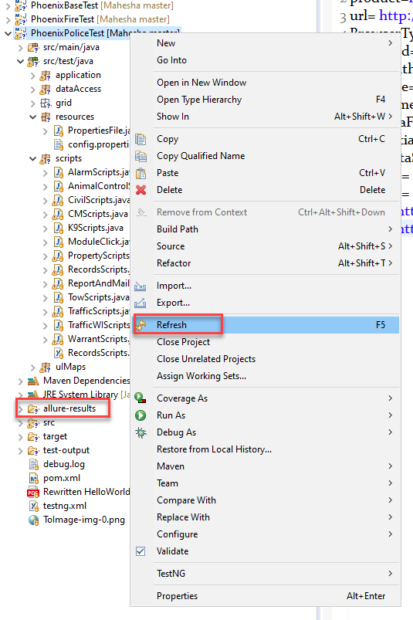

1. **Report generation process**

* **Copy the allure-results Folder path**

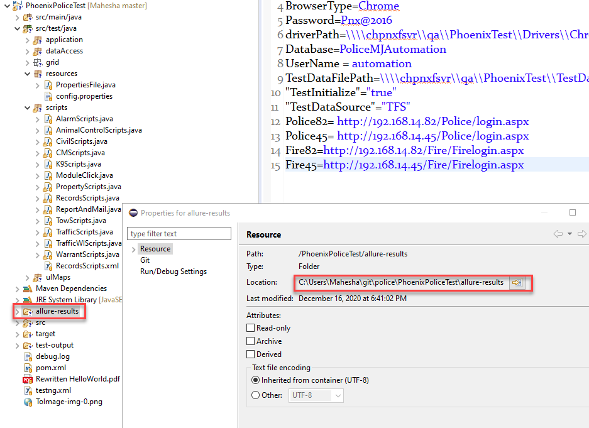

* **Open Command prompt and Trigger allure server as below commands and press enter.**

**allure serve C:\Users\Mahesha\git\police\PhoenixPoliceTest\allure-results**

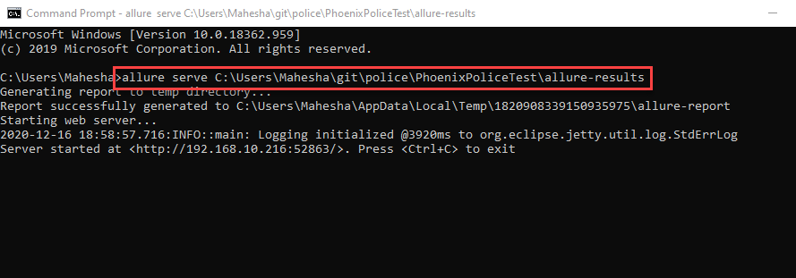

* **Finally, we can able to see our Allure report when we press enter from command prompt automatically report will generate.**

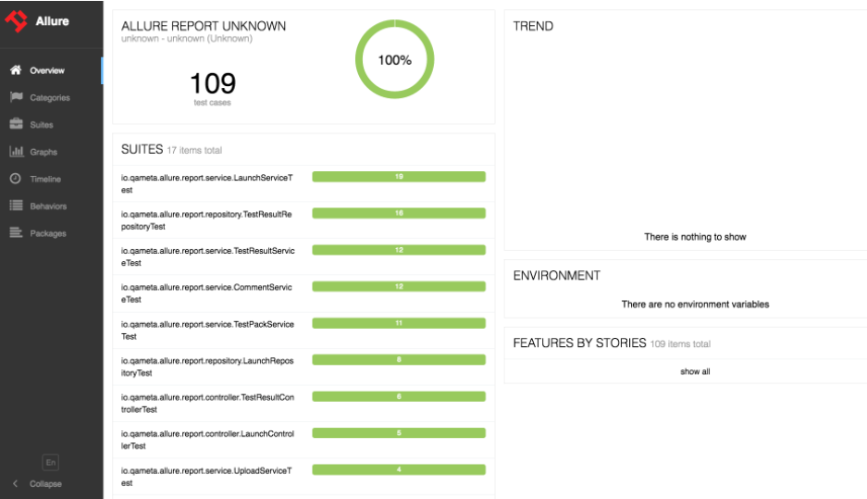

**END**

**Thanks**

**Mahesha KS**